**A**

**Kinamatics Of Machinary Report**

**On**

**‘Robotic Arm Mechanism using Servo Motor’**

## By

|  |  |  |
| --- | --- | --- |
| **Name of the Student** | **Roll. No.** | **Exam Seat No.** |
| Kakad Abhishek Satu | **23** | **S190101526** |
| Kale Abhishek Subhash | **24** | **S190101527** |
| Karle Rushikesh Shivshankar | **25** | **S190101528** |
| Kawade Ganesh Popat | **27** | **S190101530** |
| Mule Ashutosh Bhausaheb | **37** | **S190101541** |

**Under the guidance of Prof. P.H.Pathade Sir**

**Department of**

**SE(Automation & Robotics)**

**Amrutvahini College of Engineering, Sangamner-422608**

2022-2023

CERTIFICATE

Amrutvahini Sheti & ShikshanVikas Sanstha’s

**Amrutvahini College of Engineering, Sangamner**



## This is to certify that

|  |  |  |
| --- | --- | --- |
| **Name of the Student** | **Roll. No.** | **Exam Seat No.** |
| Kakad Abhishek Satu | **23** | **S190101526** |
| Kale Abhishek Subhash | **24** | **S190101527** |
| Karle Rushikesh Shivshankar | **25** | **S190101528** |
| Kawade Ganesh Popat | **27** | **S190101530** |
| Mule Ashutosh Bhausaheb | **37** | **S190101541** |

## **have completed a project on**

**“Robotic Arm Mechanism using Servo Motor”**

## under the guidance of **Prof.P.H.Pathade Sir**

**as a part of**

## Kinamatics Of Machinary during academic year 2022-2023

|  |  |  |
| --- | --- | --- |
| **Prof. P.H.Pathade** |  | **Prof.B.R.Borkar** |
| **Mentor** | **Co- Mentor (If any)** | **HOD** |

# ACKNOWLEDGEMENT

It gives us immense pleasure in bringing out the Project entitled “**Robotic Arm Mechanism using Servo Motor’’**. We express our deep sense of gratitude and sincere regards to our project mentor **Prof.­-P.H.Pathade Sir** giving his valuable supervision, cooperation and devotion of time that has given to our Project work. We are grateful to S.E.HOD **Dr.D.B.Borkar** for his facilities extended during project work and for his personal interest and inspiration.

We wish to express profound thanks to **Prof M. A. Venkatesh**, Principal Amrutvahini College of Engineering, for providing necessary facilities to make this project successful. Finally, we like to thanks all those who directly or indirectly helped us during the work. We also owe our sincere thanks to all faculty members of First year Department who have always extended a helping hand.

Kakad Abhishek Satu - S190101526

Kale Abhishek Subhash - S190101527

Karle Rushikesh Shivshankar - S190101528

Kawade Ganesh Popat - S190101530

Mule Ashutosh Bhausaheb ­- S190101541

**CONTENT**

|  |  |  |
| --- | --- | --- |
| **Sr.no** | **Name of Content** | **Page no** |
| I | Cover page/front page | 01 |
| II | Certificate | 02 |
| III | Aknowlagement | 03 |
| IV | Content | 04 |
| V | Abstract | 05 |
| 1. | Introduction | 06 |
| 2. | Project Motivation | 08 |
| 3. | Aim and Objectives | 09 |
|  | 3.1 Aim | 09 |
|  | 3.2 Objectives | 10 |
| 4. | Methodology | 11 |
|  | 1. Required tools for Project | 11 |
|  | 1. Design of Project | 16 |
|  | 1. Program Interface | 18 |
| 5. | Mechanism Specifications | 21 |
| 6. | Result and Discussion | 23 |
|  | 5.1 Advantages | 23 |
|  | 5.2 Disadvantages  5.3 Future Scope | 23  24 |
| 6. | Photos | 25 |
| 7. | Conclusions | 26 |

**Abstract**

Today, technology is developing in the same direction in line with rapidly increasing of human needs. The work done to meet these needs makes life easier every day, and these studies are concentrated in robotics studies. Actually in recent year’s scientists use the word "Robot" to mean any man-made machine that can perform work or other action normally performed by humans, either automatically or by remote control because of this robot pervasive machine because of it is accuracy of work and doing thing that people can’t do in addition robot can work in dangerous regions that human can’t work in it because of all these reason robot became one of the most popular thing that scientists still persevere to make it better by finding new controllers and designs that make robot more efficient and more reliable and in our project we have built a robot arm with **3 DOF** (degree of freedom). In fact there are several methods were implemented to make a **3-DOF manipulator using Joystick module** for capable of performing pick-and-place operations. but the problem is that all the controller is relentless that mean if we need to change the program of the arm we have to reboot and write or designs another one and upload it to arm robot this way apparently is not efficient, on balance we choose a different and unconventional method to control the robot arm by using image processor device that called (Kinect).

**Introduction**

The word robot is derived from the Czechoslovakian term robota which is generally translated as forced labor. This means that the original conception of a robot, as far the etymology Of the word is concerned, was to be a capable servant. It was first used in the play by the Czechoslovakian author Karel Capek entitled R.U.R. (Rossum's Universal Robots).

**“Robots will play an important role in providing physical assistance**

**and even companionship for the elderly.”**

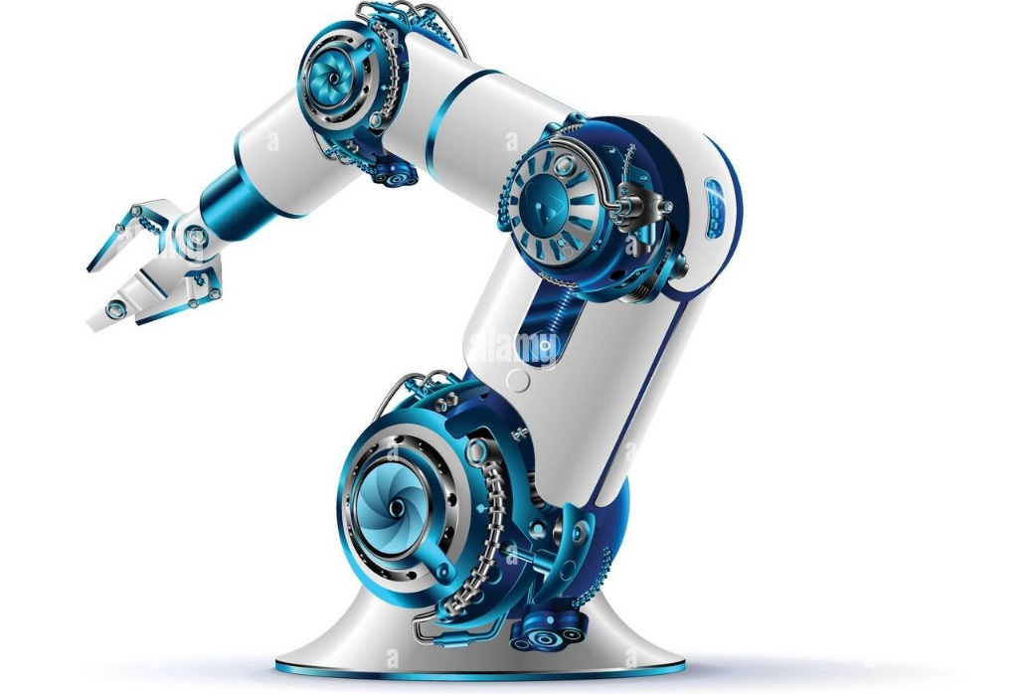**-Bill Gates**

In the play, robots were portrayed as small, artificial and anthropomorphic creatures strictly obeying their master's orders. From this humble conception, many authors began getting inspirations from the concept of a robot. The most famous of all the authors that wrote about robots is Isaac Asimov. He was the one Who formulated the four laws Of robots:

1. A robot may not injure humanity, or through inaction, allow humanity to come to harm.
2. A robot may not injure or harm a human being, or through inaction, allow a human being to come to harm.
3. A robot must Obey orders given to it by human beings, except where such orders would conflict the 0th or 1st law.
4. A robot must protect its own existence as long as such protection does not conflict With the previous laws. As time passed, people began formulating an encompassing definition of a robot.

As currently defined, robots exhibit three key elements:

1. programmability, implying computational or symbolic manipulative capabilities that a designer can combine as desired (a robot is a computer)
2. Mechanical capability, enabling it to act on its environment rather than merely function as a data processing or a computational device (a robot is a machine).
3. Flexibility in that it can operate using a range of programs and manipulates and transport materials in a variety of way.

A robotic arm is a robotic manipulator, usually programmable, With similar functions to a human arm. Servo motor is used for joint rotation. It has about same number of degree of freedom as in human arm. Humans pick things up without thinking about the Steps involved. In order for a robot or a robotic arm to pick up or move something, someone has to tell it to perform several actions in a particular order from moving the arm, to rotating the "Wrist" to opening and closing the "hand" or "fingers." so, We can control each joint through computer interface.

Some advanced robot arms make use Of Sensors like motion and pressure sensors in order for it to detect foreign obstacles and avoid breaking or dropping What it is carrying. Robot arm also vary with the type of end effector that they are using. The kind Of end effector that a particular robot arm is using is very much dependent on the kind of task the robot is designed for-

1. Blowtorches for auto assembly lines robots.
2. Drills for metal application robots.
3. Spray paints for decoration oriented robots.
4. For welding purpose.
5. For pick and place applicatio

**Project Motivation**

As manual labour is being reduced at big scale industries and factories to increase efficiency and gain profit by installing robots that can respective works.

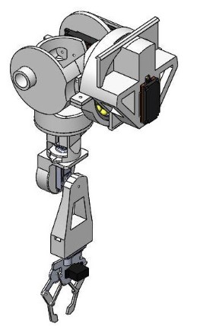

A simple robotic arm is one of the most commonly installed machines. We are introducing the basic concepts of an Arduino controlled robotic arm projects.

Robots are used in science and industry or entertain humans and although they do nots exactly looks like humans performing the tasks. In fact,some of the most popular in industry are robot manupulators which reassembles.

**Problem Statement**

It is true that human arms can do many works at a time but it always involves risk of injury during work involving lifting of heavy items and picking of radioactive substances. Moreover, medical industry need an arm for people who lost it in accidents.Also , it is seen that efficiency of a person decreases as his age advances due to which one involved in rough work becomes unproductive and inefficient .

In manufacturing industry and nuclear industry, a large fraction of the work is repetitive and judicious application of automation will most certainly result in optimum utilization of machine and manpower. A pneumatic `Pick and Place' Robot has been developed to achieve automation in applications where great sophistication is not needed and simple tasks like picking up of small parts at one location and placing them at another location can be done with great ease.

To perform its assigned tasks, the robot moves parts, objects, tools, and special devices by means of programmed motions and points. The robotic arm performs motions in space. Its function is to transfer objects or tools from point to point, as instructed by the controller.

Robotic arm is an asset for those people who are involved in nuclear industry as by robotic arms, picking of the radio substances can be done by the instructions given by them and they don’t have to physical go at the site and pick these harmful substances. Also in manufacturing industry risk of injury is prevented as now these robotic arms are involved in doing repetitive work and people of all age can control it without any loss in efficiency.

**Objective:**

The main objectives of the project are-:

1. **To be able to design and construct a robot arm.**
2. **To be able to control the robot arm using a computer through a keyboard and mouse.**

The first Object is very straightforward it requires the modern designing capacities. The complete robotic arm was first designed and assembled in designing software. We have used Wildfire ProEngineer to design 3D model Of the robot. The model is designed as per the actual dimensions Of the robot. After designing and assembling the robot in proE, Drawings are exported. Our objective is to construct physical parts Of the robot and them assemble them as we assembled in the proE. The second objective requires a working knowledge of PC to hardware communication. Additional hardware components aside from the robot arm like opt isolator circuits and limit switches Will be implemented in order to facilitate the safe 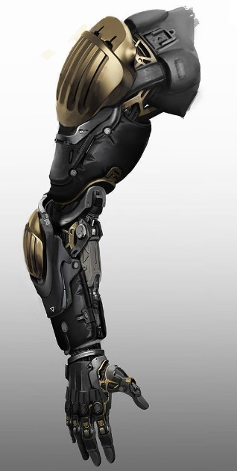control Of the arm.

An additional Objective will be to program the robot arm to do a simple task. This option, if to be implemented With accuracy and precision, requires a more challenging task of familiarizing the science of kinematics both forward and reverse kinematics.

However, the implementation used for the automation Of this robot arm is time-based.This means that when automating the robot arm, a program records the length of time Of a certain joint from moving from one position to another.

**Methodology**

**3.1 Required tools for the project:-**

1. Hardware Requirements-:
2. Ardino UNO
3. Servo Motor
4. Motor Drivers
5. Joystick Module
6. Jumping Wires
7. 9V Battery
8. Aluminium metal
9. DC Motor
10. Software Requirements-:

Ardino Software

* **Tools**

1. **Ardino UNO:-**

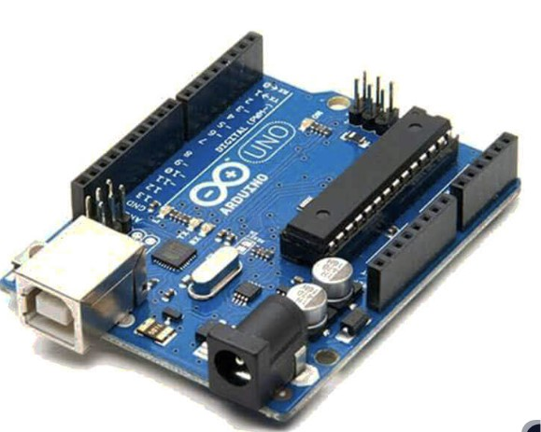 Arduino has become very popular in the world in recent times. In this project the arduino mega is used to communicate with processing and control the arm robot servos.

The causes of the spread of Arduino at such a rapid rate are:

1) it can be used on all platforms due to the simplicity of the development .

2) With the help of the advanced library, even complex operations can be easily solved.

3) There is a lot of hardware support that is compatible with Arduino and can work together.

4) Communication with the environment is easy because it is open source.

|  |  |
| --- | --- |
| **Microcontroller** | **ATmega328P – 8 bit AVR family microcontroller** |
| **Operating Voltage** | **5V** |
| **Recommended Input Voltage** | **7-12V** |
| **Input Voltage Limits** | **6-20V** |
| **Analog Input Pins** | **6 (A0 – A5)** |
| **Digital I/O Pins** | **14 (Out of which 6 provide PWM output)** |
| **DC Current on I/O Pins** | **40 mA** |
| **DC Current on 3.3V Pin** | **50 mA** |
| **Flash Memory** | **32 KB (0.5 KB is used for Bootloader)** |
| **SRAM** | **2 KB** |
| **EEPROM** | **1 KB** |
| **Frequency (Clock Speed)** | **16 MHz** |

1. **MG996 Servo Motor:-**

Servo motors are the kinds of motors that can fulfill the commands we want. They can operate steadily even at very small or very large speeds. In these motors, the large moment can be obtained from the small size. Primarily, servomotors are geared dc motors with a positional feedback control that allows the rotor (shaft) to be positioned accurately. The position control signal is a single 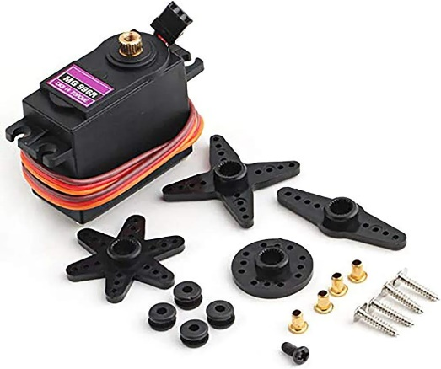variable width pulse. The pulse can be varied from 1 to 2 ms.

|  |  |
| --- | --- |
| **Operating Voltage:** | **+5V typically** |
| **Current:** | **2.5A (6V)** |
| **Stall Torque:** | **9.4 kg/cm (at 4.8V)** |
| **Maximum Stall Torque:** | **I I kg/cm (6V)** |
| **Operating speed:** | **0.17** |
| **Gear Type:** |  |
| **Rotation :** | **360** |
| **Weight Of Motor:** | **55gm** |

1. **Joystick Module:-**

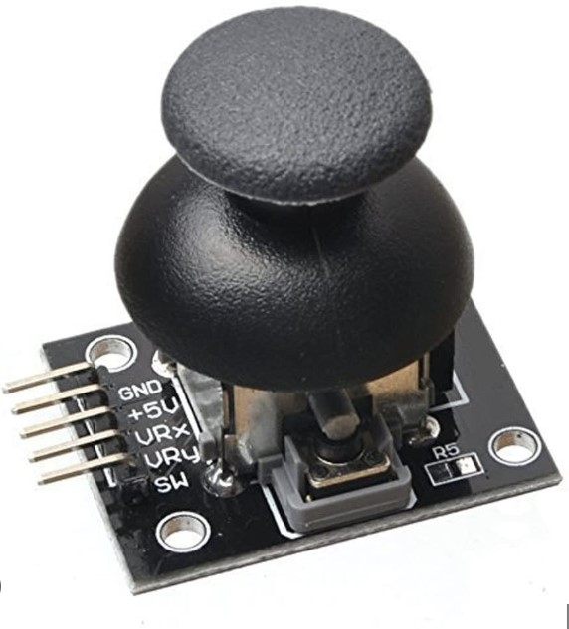 The Joystick module is similar to analog joysticks found in gamepads. It is made by mounting two potentiometers at a 90 degrees angle. The potentiometers are connected to a short stick centered by springs. This module produces an output of around 2.5V from X and Y when it is in resting position. Moving the joystick will cause the output to vary from 0v to 5V depending on its direction. If you connect this module to a microcontroller

|  |  |
| --- | --- |
| Operating Voltage | 5V |
| Internal Potentiometer value | 10K |
| Operating temperature | 0 to 70 °C |
| Potentiometer Outputs | Analog outputs range of 0 to 1023 (0v – 5v) |
| Pushbutton Output | Digital output Active Low |
| Dimensions | 40 x 27 x 15 (LxWxH) mm |
| Weight | 10gm (without Hat) |

1. 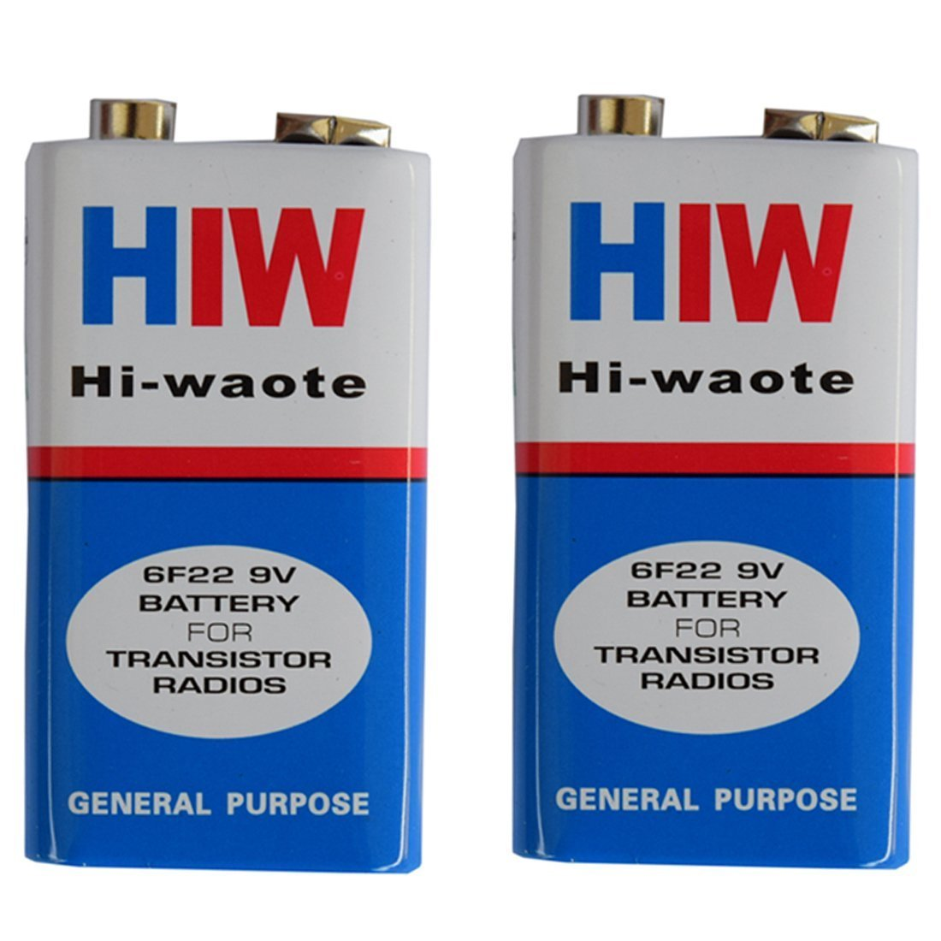**9V Battery:-**

The 9V (nine volt) battery is a rectangular dry cell classified by its 48.5mm x 26.5mm x 17.5mm dimensions and one-sided clasp terminals. They hold mid-range capacities upwards of 1,200mAh and were often used in radios, but today are used more for walkie-talkies, clocks, smoke detectors, and house alarms.

1. 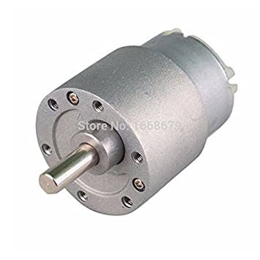**DC Motor:-**

A **DC motor** is any of a class of rotary [electrical motors](https://en.wikipedia.org/wiki/Electrical_motor) that converts direct current (DC) electrical energy into mechanical energy. The most common types rely on the forces produced by induced magnetic fields due to flowing current in the coil. Nearly all types of DC motors have some internal mechanism, either electromechanical or electronic, to periodically change the direction of current in part of the motor.

1. 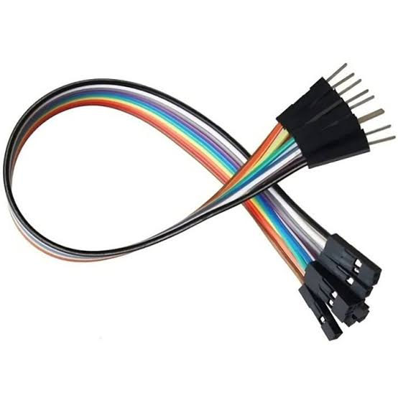**Jumping Wires:-**

A jumper wire (also known as jumper, jumper wire, DuPont wire) is an [electrical wire](https://en.wikipedia.org/wiki/Electrical_wire), or group of them in a cable, with a connector or pin at each end (or sometimes without them – simply "tinned"), which is normally used to interconnect the components of a [breadboard](https://en.wikipedia.org/wiki/Breadboard) or other prototype or test circuit, internally or with other equipment or components, without soldering.

* 1. **Design of Project:-**

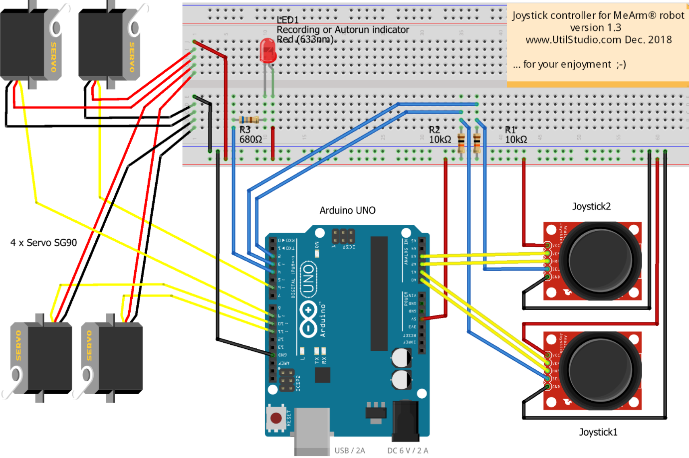

In designing machine system, it is necessary to have a good knowledge of many subjects such as Mathematics, engineering mechanics, strength of materials, theory of machines, and Engineering Drawing. Machines are always the same, they have combination of linkages, gears, belts and other mechanics and by which we make a complete mechanism to achieve a certain task.

The first step of designing a robot is to decide the dimension and workspace configuration according to the requirements. The next step is to decide the specification of each actuator. The arm is attached to a base which is the most bottom part of the robot. It is important to mention that the base ought to have considerably heavy weight in order to maintain the general balance of the robot in case of grabbing 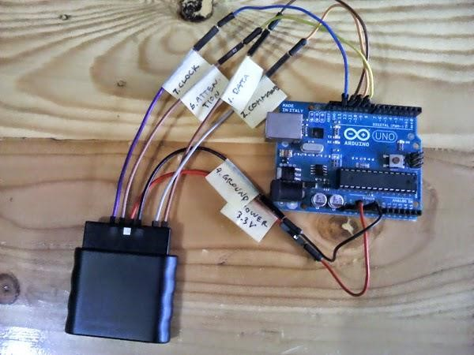an object. Although the idea of using stepper and gear motors is brilliant, but physical movement of the robot is done by using servo motors. The advantage of the servos is that they can be programmed to return to their initial position. Since the servo motors operate using the signals received from the microcontroller, they could be programmed according to the requirements.

* 1. **Program Interface:-**

Ardino Code to run the Robotic Mechanism Using Joystick

1. #include <Servo.h>
2. #include <SoftwareSerial.h>
3. // Define the servo objects
4. Servo servo1;
5. Servo servo2;
6. Servo servo3;
7. Servo servo4;
8. // Define the motor control pins
9. int motorPin1 = 6;
10. int motorPin2 = 7;
11. // Define the joystick input pins
12. int joyPin1X = A0;
13. int joyPin1Y = A1;
14. int joyPin2X = A2;
15. int joyPin2Y = A3;
16. // Variables to store joystick values
17. int joy1X, joy1Y, joy2X, joy2Y;
18. // Map joystick values to servo/motor control range
19. int servoMin = 0;
20. int servoMax = 180;
21. int motorMin = -255;
22. int motorMax = 255;
23. // Define the Bluetooth module
24. SoftwareSerial bluetoothSerial(2, 3); // RX, TX
25. void setup() {
26. // Attach the servo objects to the corresponding pins
27. servo1.attach(2);
28. servo2.attach(3);
29. servo3.attach(4);
30. servo4.attach(5);
31. // Set the motor control pins as outputs
32. pinMode(motorPin1, OUTPUT);
33. pinMode(motorPin2, OUTPUT);
34. // Initialize the serial communication
35. Serial.begin(9600);
36. bluetoothSerial.begin(9600);
37. }
38. void loop() {
39. // Read joystick values
40. joy1X = analogRead(joyPin1X);
41. joy1Y = analogRead(joyPin1Y);
42. joy2X = analogRead(joyPin2X);
43. joy2Y = analogRead(joyPin2Y);
44. // Map joystick values to servo/motor control range
45. int servo1Angle = map(joy1X, 0, 1023, servoMin, servoMax);
46. int servo2Angle = map(joy1Y, 0, 1023, servoMin, servoMax);
47. int servo3Angle = map(joy2X, 0, 1023, servoMin, servoMax);
48. int servo4Angle = map(joy2Y, 0, 1023, servoMin, servoMax);
49. int motorSpeed = map(joy2Y, 0, 1023, motorMin, motorMax);
50. // Control the servo motors
51. servo1.write(servo1Angle);
52. servo2.write(servo2Angle);
53. servo3.write(servo3Angle);
54. servo4.write(servo4Angle);
55. // Control the DC motor
56. if (motorSpeed > 0) {
57. analogWrite(motorPin1, motorSpeed);
58. analogWrite(motorPin2, 0);
59. } else if (motorSpeed < 0) {
60. analogWrite(motorPin1, 0);
61. analogWrite(motorPin2, -motorSpeed);
62. } else {
63. analogWrite(motorPin1, 0);
64. analogWrite(motorPin2, 0);
65. }
66. // Print the joystick and servo/motor values
67. Serial.print("Joystick 1 X: ");
68. Serial.print(joy1X);
69. Serial.print("  Y: ");
70. Serial.print(joy1Y);
71. Serial.print("  Joystick 2 X: ");
72. }

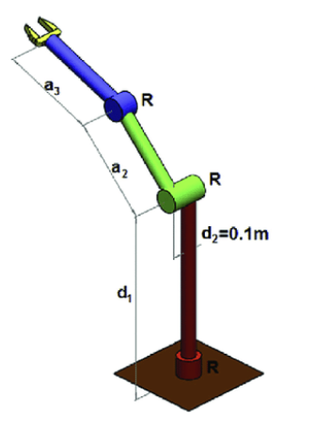**Mechanism Specifications**

A Robotic arms with 3 degrees of freedom of the robotic arm and different kinematic structures:

**(a) RRR**

**(b) RRP**

**(c) PPP**

The optimisation variables are shown for each robot structure. The arms are mounted on a mobile platform which is not considered to be part of the arm's kinematics but were included in the optimisation of the position of the robot with respect to the tree in terms of X and Y coordinate.

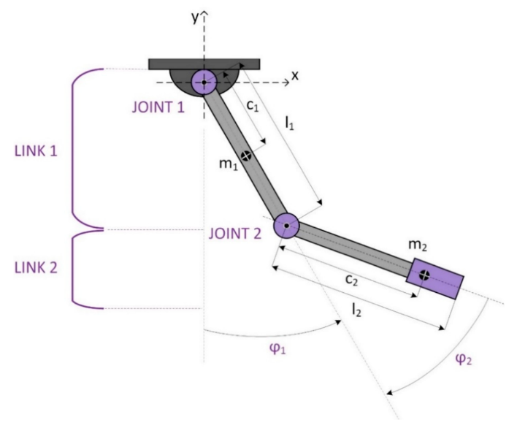

**Features:-**

* Totally 4 motos are used in this robotic arm mechanism.
* 3 Servo motors and 1 high power dc motor.
* Dc motor is being attached at sholder to get 360* moverments.
* 3 Servo motors are attached at elbow,wrist and for gripper movements.
* 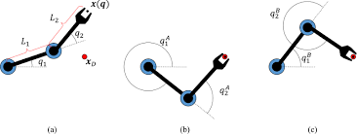All movements are being done by joystick control.

**It having 3 Degree of Freedom**

These are as follows:

1. Forward & Backward movement of Sholder.
2. Upward & Downward Movement Of Elbow
3. Ratational Movement of the wrist.

**Result and Discussion**

* **Advantages:-**

1. **Cost Effectiveness:**

There will be no lunchbreaks, holidays, sick leave or shift time allocated for robotic Improved**.**

1. **Quality Assurance:**

Robotic automation eliminates the risks of vigilance decrement by accurately producing and chocking items meet the required standard without fail.

1. **Increased Productivity:**

Due to continuous and stress less work the production will take place continuously and will boost the production.

1. **Work In Hazardous Environments:**

If a high level of chemicals are present, robotic automation offers the ideal solution, as it will continue to work without harm, even in areas that have extremely high or low temperatures Robotics will prove themselves the best

* **Limitations:-**

1. **Potential Job Losses:**

One of the biggest concerns surrounding the introduction of robotic automation is the impact of jobs for workers. If a robot can perform at a faster, more consistent rate, then the fear is that humans may not be needed at all.

1. **Initial Investment Costs:**

This is typically the biggest obstacle that will decide whether or not a company will invest in robotic automation, or wait until a later stage. The cash flow must be sustainable in the meantime and the stability of the company is by no means worth the risk if the returns are only marginal.

1. **Hiring Skilled Staff:**

Over the past decade manufacturers have found it harder to source skilled staff members to fill the specialized roles in their factories.

* **Future Scope:-**

1. If more time and more efforts would have been put into the model, more complexity could have been brought out.
2. Moreover instead of manual operation of switches and controller could have been replaced by pre-defined computer program or merely by pressing switch operated.
3. Further more varieties and more flexibility to add or replace any part according to the requirements can be done to improve its use and increase field of usage and to make it more universal or flexible.

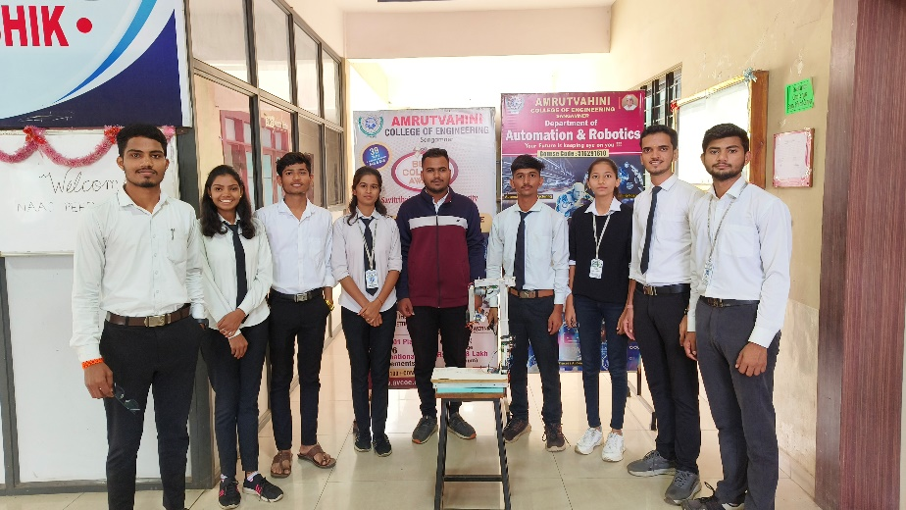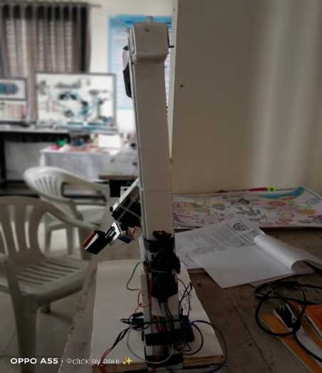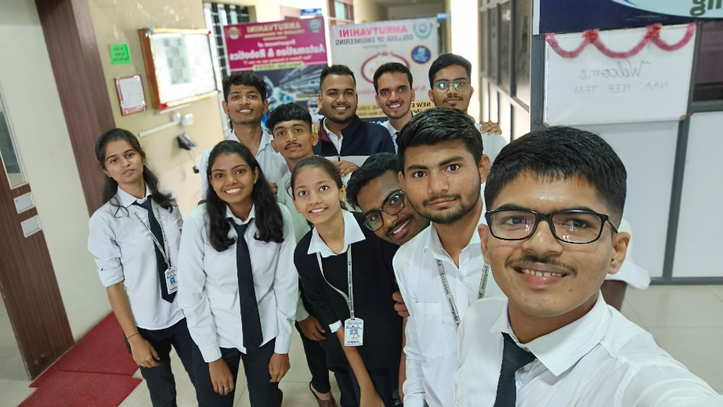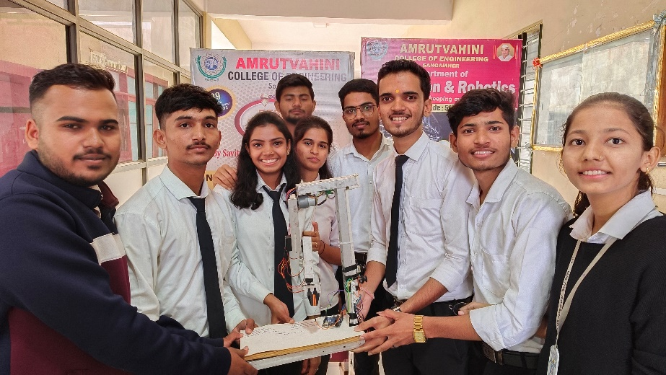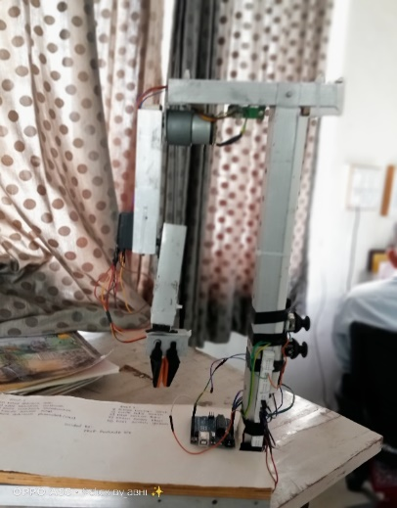**Photos**

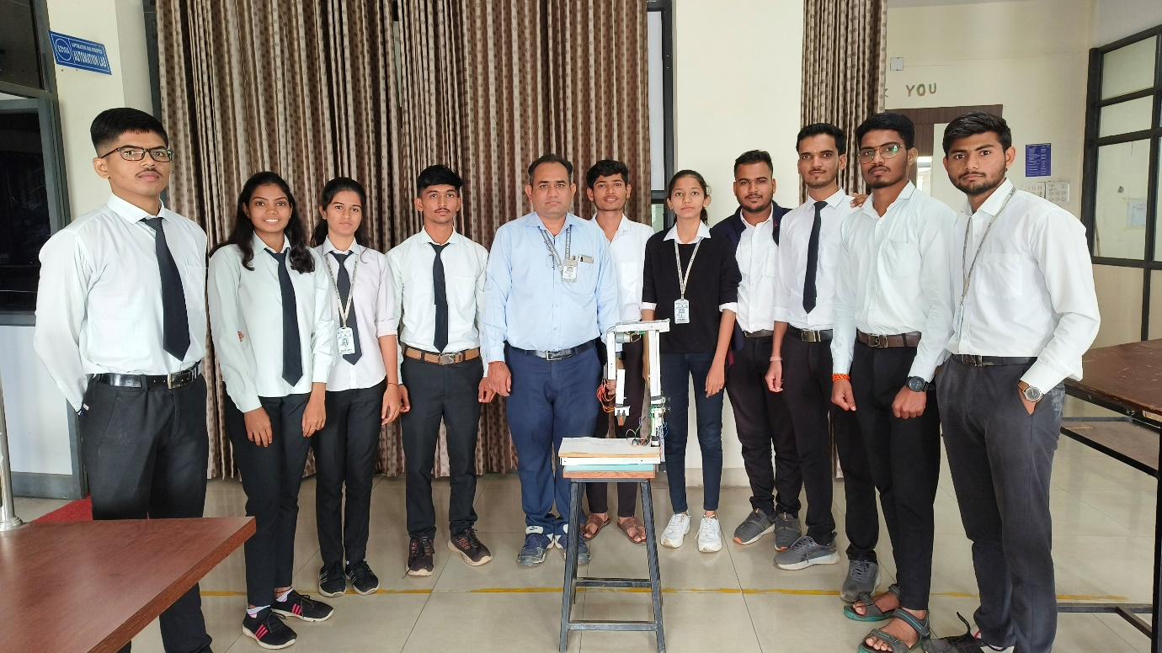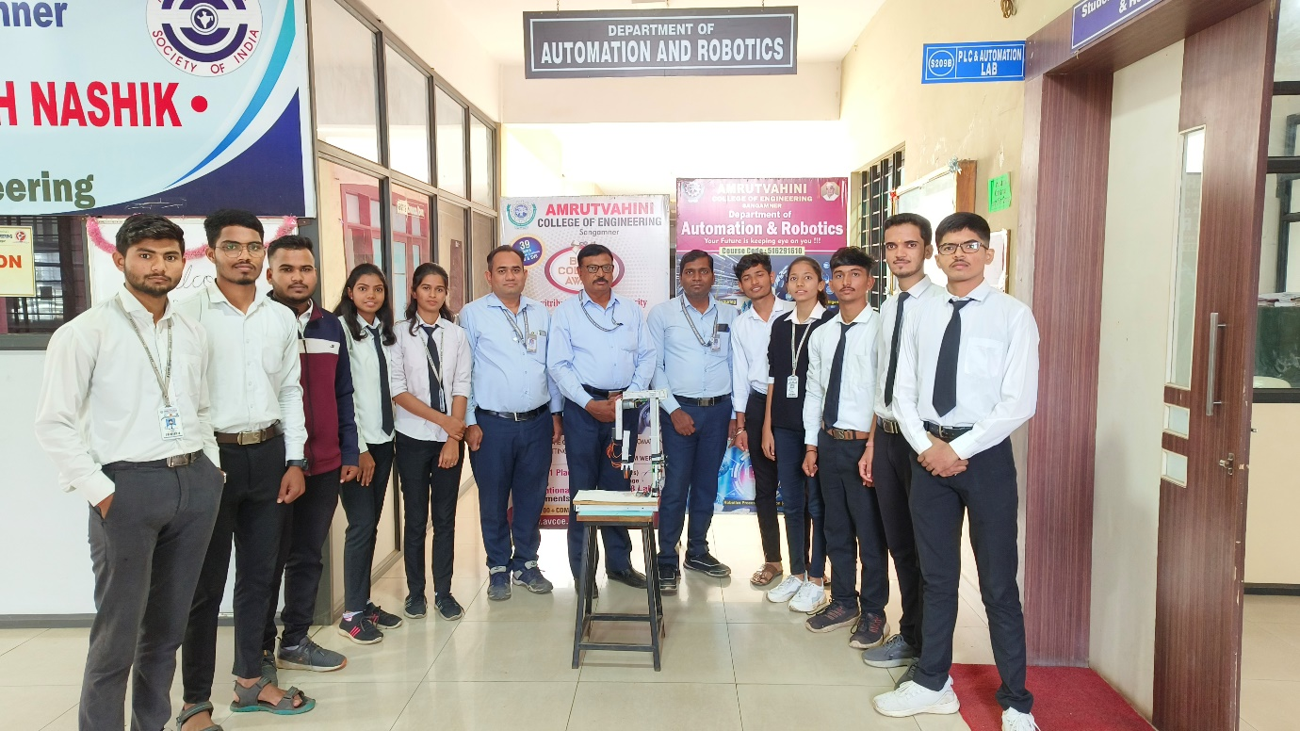

**Conclusion**

* Thus we had prepared mechanism has been successfully constrained and executed to carry out the required work of picking up the weight of the object like table tennis ball and to put them in to the placed at different location.
* This robot can be modified using some of the latest techniques to make it more flexible and addition of movable joints to increase its working capacity.
* This project is a prototype of an immense number of projects that we can use it in a lot of purposes like military, medical, social, educational, and industrial and we can use it for people with special needs.
* We also conclude that we merge more than programming language to achieve some processes to run the project as we have done in our project, we have merged the processing program with Arduino program (C) by using serial .